**Learners have to develop a Report to support the answers to the following questions and suggestions.**

**Objective Questions:**

1. **In analyzing the hospital dataset with Power BI, ensure data cleaning to address inconsistencies and missing values before further analysis.**

Ans.

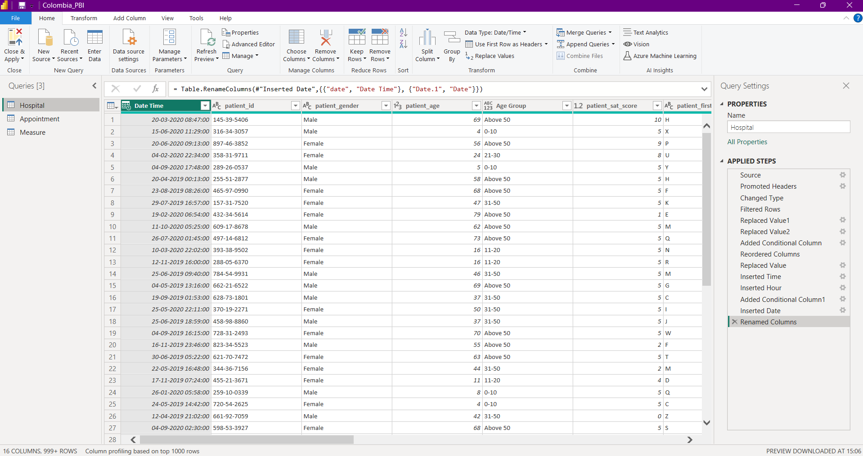

1. **Assess the Average Waiting Time: Analyse the patient wait times to identify the average duration a patient spends before receiving care.**

Ans.

With the help of the DAX formulas In Power Bi we can achieve this for this

**Average waiting Time** = AVERAGE(Hospital[patient_waittime])

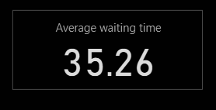

1. **Visits by Department Referral: Calculate the total number of visits to each department based on referrals to understand which departments are most frequently visited.**

Ans. With the help of the DAX formulas In Power Bi we can achieve this for this

**Visits by Department =** CALCULATE(COUNTROWS(Appointment),

ALLSELECTED(Appointment[department_referral]))

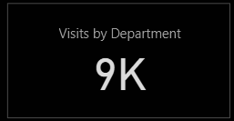

1. **Patient Visits by Age Group: Segregate patient visits according to different age groups to see which demographics utilize healthcare services the most.**

Ans.

With the Conditional column we have created an age group column and see the total visits as per the age group trend using a column chart .

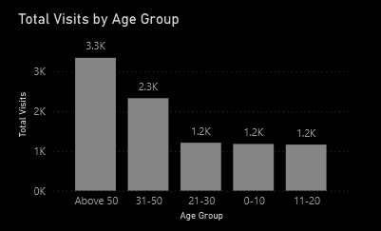

1. **Were there any Null values in the data? What would be the best way to handle these Null values and which approach have you opted for?**

Ans.

Yes there were some Null values in the Data. There are multiple ways to handle them but in this case the best possible way was to replace them with mean value.

So have replaced the SAT scores with the mean value.

1. **Is there any relation between the number of visits and the Gender of the patients?**

Ans.

To analyze the relation between Gender-wise visits , we have used visualizations by creating a column chart having Gender wise visits.

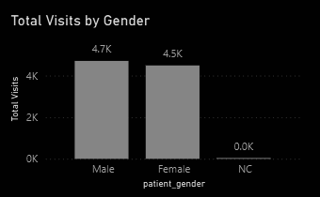

As visible in the above graph there is no such trend of visits against the patient gender both male and female patients have visited and also there were some patients who did not mention their Gender.

1. **Average Satisfaction by Demographics: Determine the relationship between patient satisfaction scores, their age groups, and racial backgrounds to pinpoint areas for improvement in patient experience.**

Ans.

To identify the average satisfaction among the patients from a particular Race and particular age group we can go forward with a table chart having patient race , age group and Average SAT Score as the columns in it.

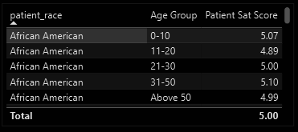

1. **The hospital's managing director seeks to evaluate the revenue of each department to understand how much revenue is generated by each.**

Ans.

To achieve this we can go on and create a new dax measure that calculates the Total Revenue and create a column visual that shows the trend with Revenue vs Department.

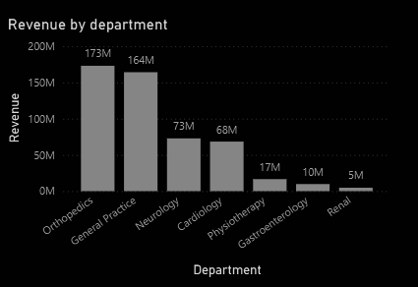

1. **Which department is charging the highest appointment fees in general? Use an aggregation DAX function to solve this question.**

Ans.

We can get the highest appointment fee by using the Max Dax function in Power BI.

**Max Fee** = MAX(Appointment[Appointment Fees])



1. **Create a tabular visualization in the Report view which consists of Month-wise total visits in the hospital. Add a third column in the table that consists of the previous month’s total visits for each month’s row. Also, include a column that states whether the visits in a month are greater than that of the previous month's visits.**

Ans.

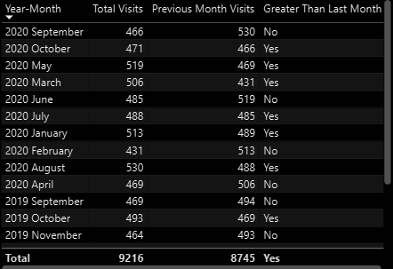

The table visual above presents a clear summary of year-month-wise total hospital visits, alongside the previous month's visit count. Additionally, it includes a flag indicating whether the current month’s visits were greater or lesser than the previous month.

This structure helps in quickly identifying growth trends, seasonal patterns, and fluctuations in patient volume, enabling better decision-making around staffing, resource allocation, and operational planning.

1. **Using ‘Calculate’ and a row iteration DAX function calculate the total number of patients who have visited Dr. Smith.**

Ans.  **DrSmith Patient Count =**

CALCULATE(

SUMX(

Appointment,

IF(Appointment[Doctor Name] = "Dr. Smith", 1, 0)

)

)

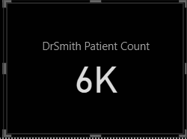

1. **Calculate the average age of the patients who visit the Orthopedics department. Will the approach used to calculate this metric be different if the requirement had been all departments’ average age?**

Ans.

Using the calculate function we can create a DAX measure to count the patients who visited the Orthopedics Department.

**Orthopedics Avg Age =** CALCULATE(AVERAGE(Hospital[patient_age]),Appointment[department_referral] = "Orthopedics")

In the case of all Departments we could have simply calculated the Average Age using the Average function and analyzed it using the KPI visual in Power BI.

**Average Age =** AVERAGE(Hospital[patient_age])

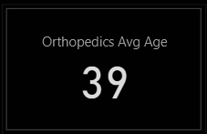 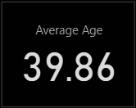

1. **Were there any data format issues in the data, and if there were/are how you handle them?**

Ans.

No, There are no as such Data Type errors in the Data.

1. **When we add a column in Power Query what’s the code that comes in M language in the formula bar? What do you know about M-query?**

Ans.

= Table.AddColumn(#"Previous Step", "New Column", each [Sales] * 2)

M Query (or just M) is the language used in Power Query.It is a tool in Power BI and Excel that helps you clean, shape, and transform data before using it in your reports.

Think of M as the behind-the-scenes code that runs when you do things like:

* Remove columns
* Filter rows
* Add new columns
* Merge tables
* Change data types

Even though Power Query has a point-and-click interface, it automatically writes M codefor every step we take.

1. **Identify the top 5 doctors who generated the most revenue but had the fewest patients. (SQL)**

Ans.

*with cte as*

*(*

*Select doctor_name, count(*) as total_patients,*

*sum(total_bill) as revenue*

*from doctor_patient_data*

*group by doctor_name*

*),*

*ranked as*

*(*

*Select doctor_name, total_patients, revenue ,*

*rank() over( order by total_patients asc, revenue desc) as rnk*

*from cte )*

*Select doctor_name, total_patients , revenue from ranked*

*where rnk<=5;*

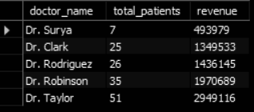

1. **Find the department where the average waiting time has decreased over three consecutive months. (SQL)**

Ans.

*with cte as*

*(*

*Select department_referral as department ,*

*date_format(date,'%Y-%m') as month ,*

*round(avg(patient_waittime),2) as avg_waittime*

*from patient_visits*

*group by department_referral, date_format(date,'%Y-%m')*

*),*

*lags as*

*(*

*Select department,*

*month,*

*avg_waittime,*

*LAG(avg_waittime,1) over( partition by department order by month ) as prev_month,*

*LAG(avg_waittime,2) over( partition by department order by month ) as prev_prev_month*

*from cte )*

*Select department,month,avg_waittime,prev_month,prev_prev_month*

*from lags where avg_waittime < prev_month and prev_month < prev_prev_month ;*

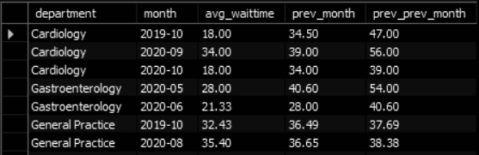

1. **Determine the ratio of male to female patients for each doctor and rank the doctors based on this ratio. (SQL)**

Ans.

*with cte as*

*( Select d.doctor_name,*

*ifnull(round(sum( case when p.patient_gender = "Male" then 1 else 0 end) / sum( case when p.patient_gender = "Female" then 1 else 0 end),2),0) as gender_ratio*

*from doctor_patient_data d join patient_visits p*

*on d.patient_id = p.patient_id*

*group by d.doctor_name )*

*Select doctor_name, gender_ratio ,*

*dense_rank() over( order by gender_ratio desc) as rnk*

*from cte ;*

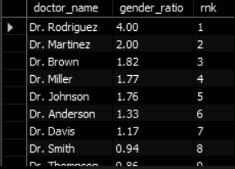

1. **Calculate the average satisfaction score of patients for each doctor based on their visits. (SQL)**

Ans.

*Select d.doctor_name,*

*round(avg(p.patient_sat_score),2) as SAT_Score*

*from doctor_patient_data d*

*join patient_visits p on d.patient_id = p.patient_id*

*group by d.doctor_name*

*order by SAT_Score desc*;

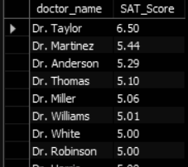

1. **Find doctors who have treated patients from different races and calculate the diversity of their patient base. (SQL)**

Ans.

*Select d.doctor_name,*

*count(distinct(p.patient_race)) as diversity_count*

*from doctor_patient_data d*

*join patient_visits p on d.patient_id = p.patient_id*

*group by d.doctor_name*

*order by diversity_count desc, doctor_name asc;*

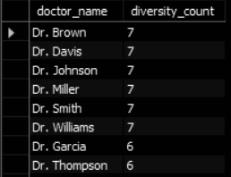

1. **Calculate the ratio of total bills generated by male patients to female patients for each department. (SQL)**

Ans.

*Select d.department_referral as department ,*

*round(sum(case when p.patient_gender = "Male" then d.total_bill else 0 end)/*

*sum(case when p.patient_gender = "Female" then d.total_bill else 0 end),2) as gender_revenue_ratio*

*from doctor_patient_data d*

*join patient_visits p on d.patient_id = p.patient_id*

*group by d.department_referral*

*order by gender_revenue_ratio desc , department asc;*

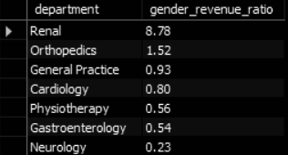

1. **Update the patient satisfaction score for all patients who visited the "General Practice" department and had a waiting time of more than 30 minutes. Increase their satisfaction score by 2 points, but ensure that the satisfaction score does not exceed 10. (SQL)**

Ans.

*UPDATE patient_visits*

*SET patient_sat_score = LEAST(patient_sat_score + 2, 10)*

*WHERE department_referral = 'General Practice'*

*AND patient_waittime > 30;*

**Subjective Questions**

1. **What is the relation between patient wait time and satisfaction scores?**

Ans.

Based on the current dataset, there doesn’t appear to be a strong or direct relationship between patient wait time and satisfaction scores. While wait time is generally considered an important factor in patient satisfaction, in this case, other elements seem to have a greater impact. These include the quality of treatment, the patient’s preferred doctor, accessibility, and overall experience. Therefore, even if the wait time is longer in some cases, patients may still report high satisfaction if other aspects of their visit meet or exceed expectations.

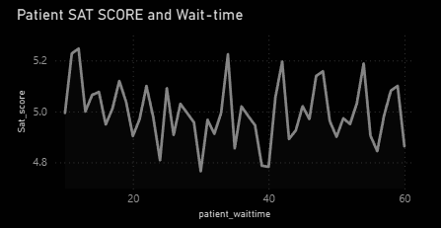

1. **How do patient demographics affect the frequency of visits to different departments?**

Ans.





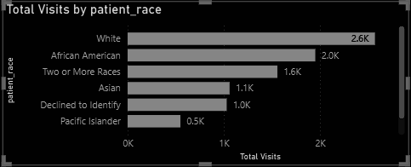

*Impact of Age Group on Visit Frequency:*

* The "Above 50" age group has the highest number of visits (~3.3K), indicating that older patients are the most frequent visitors. This could be due to age-related health conditions requiring more regular medical attention.
* The "31-50" age group follows with 2.3K visit**s**, suggesting a moderately high engagement, possibly related to lifestyle diseases or preventive check-ups.
* The younger age groups like “21-30”, “0-10”, and “11-20” have similar and comparatively lower visit frequencies (around 1.2K each). This implies that younger populations may not require frequent visits or only visit in case of acute illness or routine pediatric care.

This suggests that departments specializing in chronic disease management, or internal medicine are likely to see higher traffic, particularly from the older age segments.

### *Impact of Gender on Visit Frequency:*

* There is a fairly balanced distribution between Male (4.7K visits) and Female (4.5K visits) patients, with males showing a slightly higher number of visits.
* The difference is marginal, indicating no significant gender-based disparity in hospital visits.
* The "NC" (Not Classified) category has negligible entries, showing that gender data is well-recorded.

This implies that both male and female patients contribute nearly equally to departmental traffic, so there isn't a strong gender-based skew toward any particular department solely based on frequency of visits.

*Impact of Racial Groups on Visit Frequency*

* Among racial groups, White patients lead with 2.6K visits, followed by African American patients (2.0K) and patients of Two or More Races (1.6K).
* Asian (1.1K), Declined to Identify (1.0K), and Pacific Islander (0.5K) groups represent smaller shares of total visits.
* This variation could be due to differences in population size, access to healthcare, cultural behavior, or socioeconomic status.

This implies Departments should be aware of racial diversity in patient visits and ensure inclusiveness.

1. **Is there a noticeable trend in the volume of patient visits throughout the year?**

Ans.

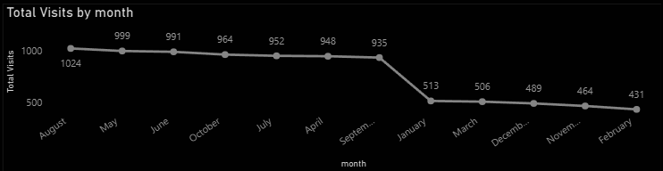

As seen in the visual above, there is a noticeable increase in the number of hospital visits starting from the month of April. Compared to the previous months, this surge is quite significant and suggests a change in patient behavior or hospital operations around that time.

**Insights:**

The rise in visits after March might be linked to seasonal factors. For example, post-winter months often bring an increase in certain illnesses or follow-up visits that were delayed earlier.

1. **Which age groups report the highest and lowest satisfaction scores?**

Ans.

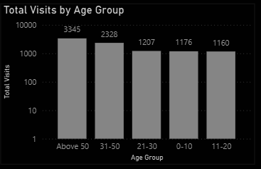

As demonstrated in the column chart above, the age group with the highest number of hospital visits is **50 years and above**, whereas the **11–20 age group** records the lowest number of visits.

**Insights:**

**Higher Visits in 50+ Age Group:**

This trend is expected, as individuals aged 50 and above typically require more frequent medical attention due to age-related health conditions and regular health checkups. This age group often has ongoing treatment plans or chronic illnesses that need consistent monitoring.

**Lower Visits in 11–20 Age Group:**

The 11–20 age group usually represents a relatively healthy population segment. At this age, individuals are less likely to suffer from chronic illnesses and often only visit hospitals for seasonal infections, minor injuries, or school-related health requirements, which might explain the lower number of visits.

1. **Say someone outside of the hospital claims that there is racial or gender-based discrimination in the hospital, how will you identify whether the claim was right or not?**

Ans.



As shown in the above bar chart, patient visits are fairly distributed across different racial groups. While the majority of patients belong to the White racial group, the volume is closely followed by African American and Asian patients.

Based on the presented data, there appears to be no evident sign of racial discrimination, as the distribution suggests that patients from diverse racial backgrounds are being served proportionately.

1. **The hospital management intends to offer discounts to patients. How should these offers/discounts be assigned to patients, on what basis, and why?**

Ans.

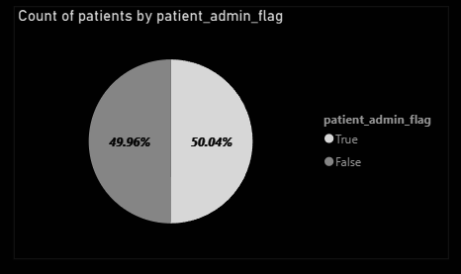

The availability of the Admin flag in the patient database provides a valuable insight into the classification of patients specifically, distinguishing between hospital staff and general public patients .

This differentiation is important because it helps the hospital identify and measure how many non-staff patients (i.e., external patients) it is successfully reaching and serving. These are the patients who directly contribute to the hospital’s revenue and community outreach.

### **Discount Strategy Based on Admin Flag**

* For patients where Admin = False, the hospital can consider offering exclusive discounts as an incentive for choosing the hospital's services.
* This not only improves patient acquisition and retention, but also reinforces a public-facing, community-oriented image.

1. **The hospital has a budget to hire 2-3 new doctors. They have asked for your suggestions on which departments they should hire.**

Ans.

The table visual displays department-wise doctor count along with average patient wait time. It is clearly visible that the General Practice department, despite having only 3 doctors, handles the highest volume of visits.

To manage this heavy workload and reduce patient wait times, it is recommended to hire 2–3 additional doctors in this department. This step will help improve operational efficiency, ensure timely consultations, and enhance the overall patient experience.

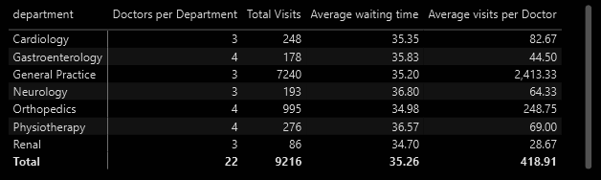

1. **Is the hospital profitable? How will you determine the profitability?**

Ans,

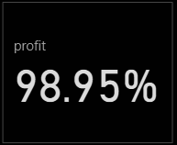

profit = DIVIDE([Revenue]-[Expense],[Revenue])

Expense = SUM(Appointment[Appointment Fees])

Revenue = SUM(Appointment[Total Bill])

The hospital appears to be operating with a strong profit margin. Based on the available data, it can be inferred that the **only significant operational cost factored into the revenue model is the doctor's appointment fee**. This cost is **excluded** from the reported total revenue, meaning that the remaining portion essentially represents **net profit**.

1. **Any Department for which the waiting time is oddly large?**

Ans.

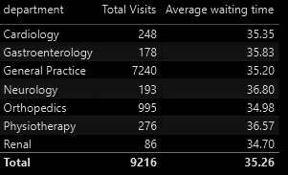

As observed in the above table visual, which summarizes department-wise total visits and average patient wait times, departments like **General Practice** and **Orthopedics** show an average wait time of approximately **35 minutes**. Given their significantly high patient volumes, this level of wait time appears justified and within operational expectations.

However, a notable exception is the **Renal** department. Despite recording only **86 total visits**, the average wait time stands at **34.70 minutes**, which is disproportionately high compared to its patient load. This anomaly suggests potential inefficiencies or operational bottlenecks within the Renal department

1. **Come up with strategies to provide discounts to the patients.**

Ans.

Offering discounts in a hospital setting goes beyond just reducing costs—it plays a crucial role in enhancing patient trust, accessibility, and loyalty, while ensuring that hospital operations remain sustainable. Following are some effective and patient-centric discount strategies that can be implemented:

* **First-Time Visit Discounts** Offering a small discount to first-time visitors encourages new patients to try the hospital’s services and helps in building long-term relationships.
* **Referral-Based Discounts** Incentivizing patients to refer friends and family members can increase patient footfall through organic word-of-mouth marketing.
* **Family or Group Discounts** Providing discounts for family health packages or group consultations encourages collective preventive care and brings multiple registrations at once.
* **Follow-Up Visit Discounts** Reduced consultation fees for follow-up visits within a certain time frame improve care continuity and patient satisfaction.
* **Senior Citizen Discounts** Special pricing for elderly patients helps address their frequent healthcare needs while reinforcing the hospital’s commitment to inclusive care.
* **Subscription Plans**Hospitals can introduce prepaid wallets or monthly/yearly subscription models where patients receive added value for upfront payments.

1. **Say you need to align the doctors of the “General Practice” department to work in one of the two shifts, how will you identify what will these two shifts' timings be, and how will you divide the doctors in these two shifts? And also will this 2 shift policy be helpful for the hospital?**

Ans.

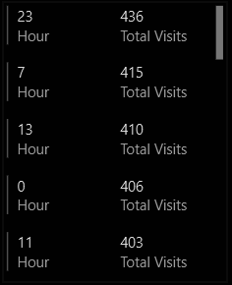

Looking at the patient and hospital interaction data, it’s clear that the *General Practice* department handles a heavy load around 400 visits a day on average. With such high footfall, it becomes really important to ensure that doctors are consistently available to meet the demand.

#### *Suggestion: 12-Hour Rotational Shifts*

To handle this volume better, I suggest implementing *two 12-hour shifts:*

* *Shift 1:* 12:00 AM – 12:00 PM
* *Shift 2:* 12:00 PM – 12:00 AM

This setup would help in a few key ways:

* Doctors would be more accessible throughout the day and night, reducing patient wait times.
* It would **s**pread the workload more evenly among the staff, preventing burnout.
* Hospital management and POCs could track each doctor’s performance moreeffectively, since work hours and patient flow would be more organized.

Overall, this change could make the hospital run more smoothly and help improve both staff efficiency and patient satisfaction.

1. **What do you understand by PowerBI gateway? What are its use cases?**

Ans.

Power BI Gateway is a bridge that enables secure communication betweenon-premises data sources and cloud-based Microsoft services like Power BI, Power Apps. It allows organizations to connect and refresh on-prem data in Power BI reports without uploading data to the cloud manually.

There are two types of gateways:

*Standard (Enterprise)* – Used by multiple users and services.

*Personal Mode* – Used by individual users, only for Power BI.

### **Key Use Cases**

*Scheduled Data Refresh* Automates the refresh of reports and dashboards using on-premises data like SQL Server, Oracle, or Excel files stored locally.

*Live or Direct Query Connection* Enables real-time dashboards by allowing Power BI to directly query on-prem systems such as SQL Server or SSAS.

*Power Platform Integration* Supports Power Apps and Power Automate to trigger actions or collect data involving on-prem systems.

1. **How would you approach this problem, if the objective and subjective questions weren't given?**

Ans.

In the provided scenario I would have followed the following Steps to present the insights from the data.

**Understanding the Dataset and Cleaning the Data**

* Will begin by thoroughly reviewing the dataset to understand the nature of the data available such as patient demographics, department details, visit timestamps, satisfaction scores, and wait times.
* Identify data types, missing values, inconsistent formats, and perform necessary cleaning or transformations.

**Defining Potential Business Questions**

* Derive relevant questions based on the available columns and overall healthcare context.  
  + Which patient demographics visit the hospital most frequently?
  + Which departments handle the highest patient volume?
  + How does wait time correlate with patient satisfaction?
  + Are there any underutilized or overburdened departments?

**Defining the Key Metrics**

* Use visual and statistical techniques to identify trends, patterns, and anomalies in the data.
* Analyze metrics like:  
  + Total visits by age group, gender, and race.
  + Department-wise and doctor-wise visit distribution.
  + Average wait time and satisfaction score by department or demographic group.
  + Monthly or daily trends in patient flow.

**Developing Visual Reports or Dashboards**

* Afterwards building interactive reports using tools like Power BI to display insights in a clear and intuitive manner.
* Include visuals such as bar charts, pie charts, line graphs, and KPI cards.
* Use filters and slicers to enable deeper analysis by department, time, or demographics.

**Interpreting and Communicating Findings**

* Interpret trends in both a data-driven and contextual manner.
* Present conclusions that help stakeholders make informed decisions (e.g., resource allocation, department planning, patient experience improvements).

1. **Can you analyze and write the type of relationship between the doctor id and department, is it one-to-one?**

Ans.

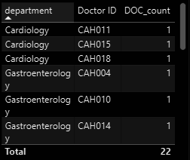

Based on the above table visual that displays the Department, Doctor_ID, and the count of each Doctor_ID, it is evident that each department is associated with a unique doctor. For every department listed, there is only one corresponding Doctor_ID, and no department appears multiple times across different doctors.

This pattern suggests that no department is linked to multiple doctors, and each doctor serves only one department. Therefore, the relationship between Department and Doctor_ID can be identified as a one-to-one relationship.